DIGITAL PREP

Clue QRs
- url
- qr img
- clue text

- Clue 1:
  - url:
  - img
  - text: the proof that tony stark has a heart
- Clue 2:
  - url
  - img
  - text: pop the balloons!

Puzzle QRs
- url
- qr img
- puzzle text - its a question
- expected answer - to read from input and check against
- clue text - if answer is correct, display this text

- wario QR
  - url: http://192.168.2.227:8005/qr-wario.html
  - puzzle text: What is Wario’s hobby?
  - answer: 32
  - clue text: Search our magazine collection
- one piece QR
  - url: http://192.168.2.227:8005/qr-one-piece.html
  - puzzle text: Find the One Piece
  - answer: 356214
  - clue text: the treasure is under the sea
- pinball QR
  - url: http://192.168.2.227:8005/qr-pinball.html
  - tiny url: https://tinyurl.com/5n6hwb3k
  - puzzle text: the glitch took over, but the score remains
  - answer:
  - clue text: under Inky, Blinky and Clyde

Cart QRs
- url:
- qr img:
- challenge text - what you need to achieve
- expected answer - to read from input and check against
- glitch password cypher - cypher for the glitch deactivation sequence
- clue text - clue to find the next cart

- Mario Cart #1 (from a QR)
  - Location: Iron man’s heart
  - url: http://192.168.2.227:8005/cart-mario.html
  - challenge text: How many goombas in level 1-3
  - expected answer: 3
  - glitch cypher: L
  - clue text: look inside the mario’s block, under the lid (bubble bobble)
- Bubble Bobble Cart #2
  - Location: inside the mario’s block
  - url: http://192.168.2.227:8005/cart-bb.html
  - challenge text: How many enemies in level 16 for 2 players:
  - expected answer: 7
  - glitch cypher: 9
  - clue text: Take out the Master Sword (Mario world)
- SF Cart #3
  - url:
  - img:
  - challenge text: Playing with Ken, who is the second rival ? (stage 9)
  - expected answer: sakura
  - glitch cypher: R
  - clue text: between books 2 and 3
- Zelda NES #3
  - Location: Nana: Book 5 Page 80
  - url: http://192.168.2.227:8005/cart-zelda.html
  - challenge text: ↑ → ↑ ↑ ↑ ↑ ← ← Find the code
  - glitch cypher: 3
  - clue text: -
- Buster Bros Cart #4 (from QR)
  - Location: Inside a baloon
  - url: http://192.168.2.227:8005/cart-pang.html
  - challenge text: How many balls in level 1-12
  - expected answer: 6
  - glitch cypher: 7
  - clue text: Nana: Book 5 Page 80 (zelda)
- Super mario world #5
  - Locatoin: inside master sword lego (from bubble booble)
  - url: http://192.168.2.227:8005/cart-mario-world.html
  - challenge text: Find the code
  - glitch cypher: F
  - clue text:

Glitch website
- url
- glitch BG
- deactivation mode: CTRL + SHIFT + O
- password/security code: L93VF

IMPRIMIBLES
- QR clues x2
- QR puzzles x3
- QR wifi
- cartuchos x4
- glitch override code (puede estar escrito a mano)
- partitura

STAGE

- tele:
  - consola encendida en el menu
  - chuleta con los controles
  - mando en caja bajo llave
  - QR WARIO pegado al lateral
  - quitar pilas al mando y repartir por la habitación
- pinball
  - glitch en la pantalla
  - puntuacion en el backglass
  - partitura escondida debajo de los packman
  - QR PINBALL pegado al lateral
- recreativa
  - encendida en el menu
  - con papel colgado en la pantalla: INSERT COIN, y cerdito hucha delante
  - chuleta con los controles
  - QR ONE PIECE pegado al lateral
- piano
  - encendido
  - pegatinas de flechas en las notas
- QRs de pistas x2
  - pegados por ahi da un poco igual donde
- mesa
  - QR de la wifi bien visible
  - portatil encendido con la web del glitch en pantalla completa
- tokens escondidos
  - llave entre las revistas de hobby consolas
  - moneda en la pecera
  - partitura bajo los packman
  - glitch DEACT. CODE en el caballo
  - cartucho 1 detras del iron man
  - cartucho 2 dentro de un globo
  - cartucho 3 en el taburete del mario bajo doble fondo
  - cartucho 4 entre los comics de sakura
  - cartucho 5 en la espada de lego de link
- google home
  - preparado para hacer text to speech

GUION
- Jill: Greetings gamers. My name is Jill. I am a benevolent AI designed to guide you. You may have noticed something strange in the arcade room - an adversarial AI, known as “the glitch”, has gained self consciousness and is attempting to take over every electronic device, thus gaining control over humanity.
- Jill: I have activated our failsafe override routine, which will leave it exposed for exactly one hour. Only within that time frame you can perform the deactivation procedure, eliminating the threat.
- Jill: Since the glitch can comprehend human language, I shall deliberately not give any details about this procedure. Instead, I have left a series of clues around the room, to guide you into the necessary step. Good luck!

Intro (revisited):

- Greetings, players. I am Jill, your guide and ally. Something dangerous lurks in the arcade—a rogue AI called “The Glitch.” It has awakened, hungry for power, and now it’s spreading through every game, every screen, aiming to seize control of all technology…and humanity itself.
- I have triggered our failsafe override. This will leave The Glitch vulnerable, but only for one hour. In this short window, you must complete the deactivation procedure to end its threat.
- However, The Glitch understands human language, so I cannot reveal the steps directly. Instead, I have hidden clues around the room to guide you. Follow them carefully. Time is ticking. Good luck!

When deactivation code input:
- parar musica
- Jill: DEACTIVATION INITIATED, PLEASE ENTER SECURITY CODE
- intense music on

If TIME’S UP!
- intenserer music on
- Jill: We are running out of time, only ten minutes left!
- Jill, if time < 2min : I managed to extend the override mode for an additional 30 minutes. Please hurry up, as I won’t be able to do this again.

If WIN:
- suena FF fanfare
- apagar pinball, encender luces
- Jill: Congratulations, the glitch has been deactivated, you have saved the world. On behalf on Aperture Science, I relay their most sincere gratitude, and the assurance that they will really really really try that this episode does not repeat. Again. Good bye.

GAME GRAPH

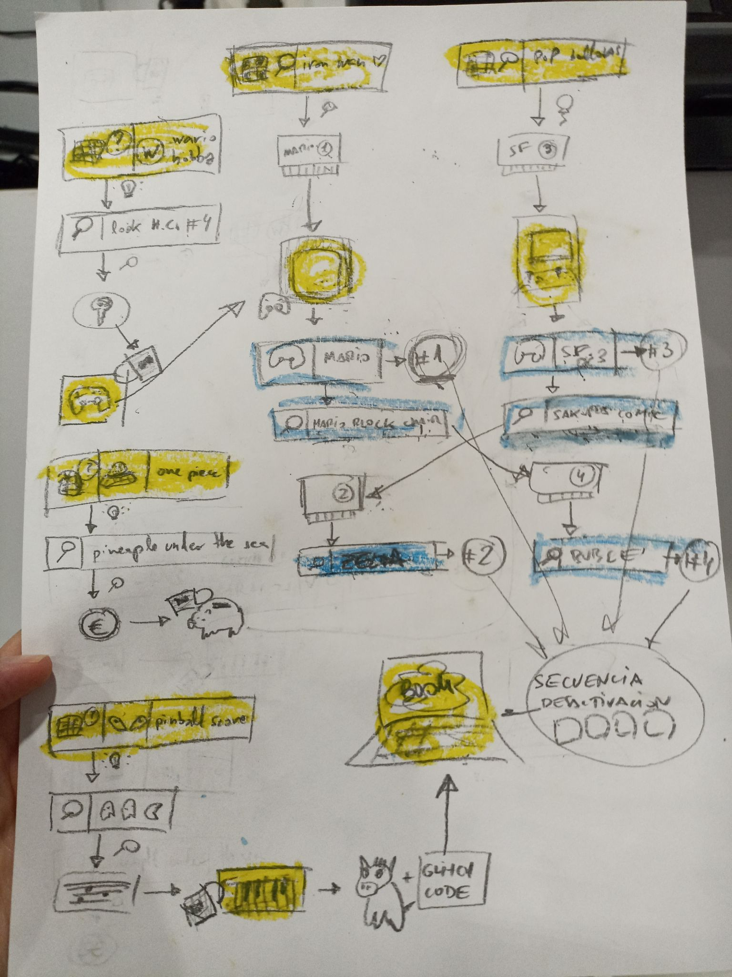

—------------------------------

web del glitch:
- se ve al glitch
- al pulsar un atajo de teclado se entra en el OVERRIDE MODE - aparecen X casillas
- al introducir cada caracter de la secuencia sale un * como si estuvieras escribiendo un pass
- al introducir todos, feedback de si es correcto o incorrecto

QR0: pista glitch
- MENSAJE: override mode: CTRL+ALT+O

QR1: pista llave 1 (mando)
- MENSAJE: the proof that tony stark has a heart →llave1
- llave1: caja con el mando

QR2: pista partitura
- MENSAJE: pop the balloons!
- inside a balloon: partitura
- al tocar la partitura: viene epona con una llave atada al cuello. La llave abre algo donde esta la moneda

QRs 3+: room puzzles+acertijos de juegos
- MENSAJE + INPUT →MENSAJE
eg: “what is warios hobby” –resp-> 1. enemigos bubble bobble nivel 16

room puzzles:
- hint: one piece / resp: secuencia de numeros de manga
- hint: what is wario’s hobby / resp: 32
- hint: pop the baloons

acertijos de videojuegos:
- enemigos del bubble bobble en nivel 16: 7
- goombas in mario 1-1: 16
- tmnt arcade 3r nivel “ONE WAY” →
- tmnt arcade 3r nivel “how many MPH?”: 20
- buster bros 2pl: numero de pelotas en nivel 1-10: 2
- buster bros 2pl: numero de pelotas en nivel 1-12: 6

- super mario bros: how many columns at the end of world 2-1: 2
- how many rings to get in first round of bonus level in sonic 2: 40
- how many hits to defeat sonic the hedgehog first boss: 8

—--

Pista cart1: proof that iron man has a heart
Pista cart2: pop the balloons
Pista cart3: ken’s last rival, book X page Y
Pista cart4: if you played as them, find them in the room and look behind

Puzzle wario: what is wario’s hobby? - R: fila y col -> find the phisical magazines
Puzzle one piece: find the one piece - R: secuencia de comics -> find the treasure under the sea
Puzzle pinball: the glitch took over, but the score remains - R: puntuacion del pinball -> look under inky, blinky and inky

